

TRIBHUVAN UNIVERSITY
INSTITUTE OF ENGINEERING

HIMALAYA COLLEGE OF ENGINEERING
CHYASAL, LALITPUR

Lab Report No: - 7
Title: - Exception handling and Stream computation

Submitted by: - Submitted To: -
Name: - Atul Bhattarai Department Of Computer and Electronics
Roll NO: - HCOE 081 BEI 011 Checked by: -
Date of submission: -

Objective
- To understand and implement exception handling using try, catch, and throw in C++.
- To perform basic input/output stream manipulations and computations using file and console streams.
Theory

Exception Handling in C++
Exception handling is a mechanism in C++ that allows a program to respond to runtime errors or unusual situations gracefully, instead of terminating abruptly. It separates normal code logic from error handling, making the program more reliable and easier to maintain.
The basic components of exception handling in C++ are:
- try block: Contains the code that may potentially throw an exception. It is used to wrap operations that need monitoring for errors.
- throw statement: Used to signal the occurrence of an exception. It transfers control from the try block to the matching catch block.
- catch block: Handles the exception thrown. Multiple catch blocks can be used to handle different types of exceptions.
This mechanism supports type-based handling, meaning specific types of exceptions can be caught (e.g., int, float, string, or even user-defined classes).
Benefits of Exception Handling:
- Improves program robustness
- Helps to separate error handling from regular logic
- Supports propagation of errors across function calls
- Ensures proper resource cleanup when used with destructors
Example Scenario:
Dividing a number by zero is undefined and can crash a program. By using exception handling, we can throw an error message and terminate the operation safely without crashing the program.
Stream Computation in C++
Streams in C++ are objects that facilitate input and output operations. These are part of the standard C++ library and enable communication with:
- the keyboard and screen (console),
- files stored on disk, and
- in-memory buffers (e.g., stringstreams).

Types of Streams:
- Standard Input/Output Streams:
  - cin: standard input stream (keyboard input)
  - cout: standard output stream (console output)
  - cerr: for error messages (unbuffered)
  - clog: for error messages (buffered)
- File Streams:
  - ifstream: input file stream (read from file)
  - ofstream: output file stream (write to file)
  - fstream: combined input and output stream
- String Streams:
  - stringstream: used for in-memory string manipulation (similar to file I/O)

Stream Computation:
Stream computation refers to using these stream objects to perform operations on data as it flows in or out of the program. Examples include:
- Reading numeric values from a file
- Writing formatted output to a file
- Calculating sums, averages, or parsing data during I/O
- Converting between strings and numbers using stringstreams
Importance in Real World:
- File streams are used in applications that handle data storage, logs, and reports.
- String streams are useful for parsing user input, serialization, or text formatting.
- Stream-based processing is efficient and scalable for large data operations.
By mastering both exception handling and stream computation, a C++ programmer can create robust applications that are not only safe from unexpected errors but also capable of reading and writing data efficiently for real-world tasks such as file processing, data logging, and user interaction.
Lab Assignment
Q1. Write a program to show exception handling inside a class constructor and destructor. Handle constructor exceptions properly; avoid throwing from destructor.
#include <iostream>
#include <stdexcept>
using namespace std;

class Sample {
public:
Sample(int x) {
cout << "Constructor called.\n";
if (x < 0) {
throw runtime_error("Negative value not allowed in constructor.");
}
}

~Sample() {
cout << "Destructor called.\n";
// Destructors should not throw exceptions
}
};

int main() {
try {
Sample obj(-1); // This will throw
}
catch (const exception &e) {
cout << "Exception caught: " << e.what() << endl;
}

return 0;
}
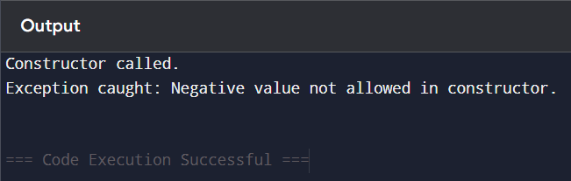
Q2. Write a C++ program to handle divide-by-zero exception using try-catch block. Input two numbers. If denominator is zero, throw and catch an exception.
#include <iostream>
using namespace std;

int main() {
int num, denom;

cout << "Enter numerator: ";
cin >> num;
cout << "Enter denominator: ";
cin >> denom;

try {
if (denom == 0)
throw "Division by zero error!";
cout << "Result: " << num / denom << endl;
}
catch (const char* msg) {
cout << "Exception: " << msg << endl;
}

return 0;
}
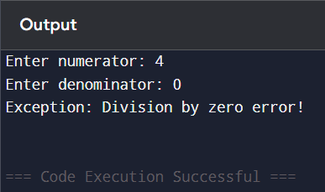
Q3. Write a program to store and retrieve 'n' recordsof items (item_ID, name, price, mfd_date, company) in Inventory system.
#include <iostream>
#include <fstream>
using namespace std;

struct Item {
int item_ID;
char name[30];
float price;
char mfd_date[20];
char company[30];
};

int main() {
int n;
cout << "Enter number of items: ";
cin >> n;

Item item;
ofstream out("inventory.dat", ios::binary);
for (int i = 0; i < n; i++) {
cout << "\nEnter details for item " << i + 1 << ":\n";
cout << "ID: "; cin >> item.item_ID;
cout << "Name: "; cin.ignore(); cin.getline(item.name, 30);
cout << "Price: "; cin >> item.price;
cout << "Mfd Date: "; cin.ignore(); cin.getline(item.mfd_date, 20);
cout << "Company: "; cin.getline(item.company, 30);
out.write((char*)&item, sizeof(item));
}
out.close();

ifstream in("inventory.dat", ios::binary);
cout << "\nStored Item Records:\n";
while (in.read((char*)&item, sizeof(item))) {
cout << "\nID: " << item.item_ID
<< "\nName: " << item.name
<< "\nPrice: " << item.price
<< "\nMfd Date: " << item.mfd_date
<< "\nCompany: " << item.company << endl;
}
in.close();

return 0;
}

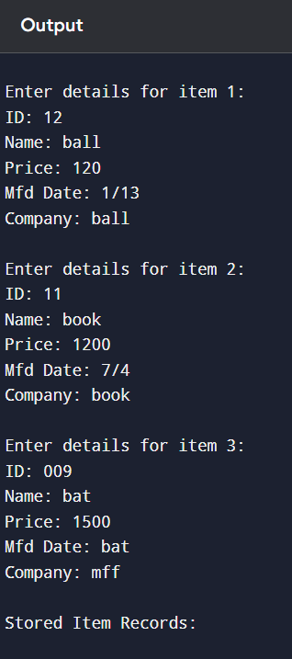
Q4. Write a program to make simple library management system of a college. Your program should store and retrieve the information (Book Name, Book ID, Number of books and purchase date).
#include <iostream>
#include <fstream>
using namespace std;

struct Book {
int book_ID;
char book_name[50];
int quantity;
char purchase_date[20];
};

int main() {
int n;
cout << "Enter number of books: ";
cin >> n;

Book book;
ofstream out("library.dat", ios::binary);
for (int i = 0; i < n; i++) {
cout << "\nEnter details for book " << i + 1 << ":\n";
cout << "Book ID: "; cin >> book.book_ID;
cout << "Book Name: "; cin.ignore(); cin.getline(book.book_name, 50);
cout << "Quantity: "; cin >> book.quantity;
cout << "Purchase Date: "; cin.ignore(); cin.getline(book.purchase_date, 20);
out.write((char*)&book, sizeof(book));
}
out.close();

ifstream in("library.dat", ios::binary);
cout << "\nStored Library Records:\n";
while (in.read((char*)&book, sizeof(book))) {
cout << "\nBook ID: " << book.book_ID
<< "\nBook Name: " << book.book_name
<< "\nQuantity: " << book.quantity
<< "\nPurchase Date: " << book.purchase_date << endl;
}
in.close();

return 0;
}
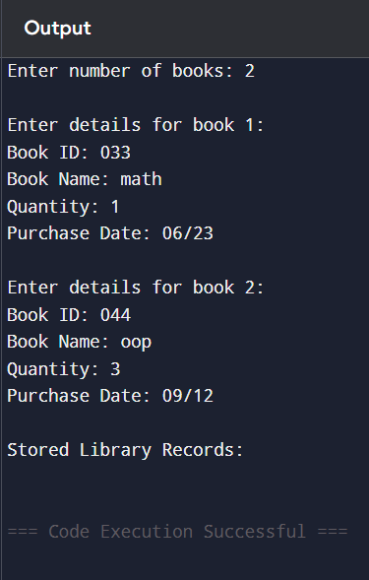

Discussion
Exception handling allowed safer code execution, especially for unpredictable inputs like division. Stream I/O enabled data persistence and processing of external data, simulating real-world applications. This exercise demonstrated how modern C++ supports both robustness and scalability in program design.
Conclusion
The lab successfully illustrated exception handling and stream computation in C++. Handling runtime errors with exceptions improves program reliability, while streams enable data operations across files and memory. These concepts are crucial for building fault-tolerant and data-driven applications.

